**Forward genetic crosses and bulk segregant genomic analyses reveal genetic mediators of multi-drug resistance in the gastrointestinal pathogen** ***Haemonchus contortus***

## 

Stephen R. Doyle*, Roz Laing*, David Bartley, Alison Morrison, Nancy Holroyd, Kirsty Maitland, Alistair Antonopoulos, Collette Britton, Umer Chaudhry, Sue Howell, Andy Tait, Barbara Mable, Ray Kaplan, Neil Sargison, Matthew Berriman, James A. Cotton, Eileen Devaney

*These authors contributed equally

## Abstract

## 

## 

## 

## 

## 

## 

## Keywords

*Haemonchus contortus*, helminth, anthelmintic resistance, genetic cross, forward genetics, ivermectin, levamisole, benzimidazole, genome-wide association, *cky-1*

## Author list

Stephen R. Doyle & Roz Laing: joint first authors

**Wellcome Sanger Institute, Hinxton, Cambridgeshire, CB10 1SA, United Kingdom**

Stephen R. Doyle: [sd21@sanger.ac.uk](mailto:sd21@sanger.ac.uk)

James A. Cotton: [jc17@sanger.ac.uk](mailto:jc17@sanger.ac.uk)

Nancy Holroyd: [neh@sanger.ac.uk](mailto:neh@sanger.ac.uk)

Matthew Berriman: [mb4@sanger.ac.uk](mailto:mb4@sanger.ac.uk)

**Institute of Biodiversity Animal Health and Comparative Medicine, College of Medical, Veterinary and Life Sciences, University of Glasgow, Garscube Campus, Glasgow, G61 1QH, United Kingdom**

Roz Laing: [Rosalind.Laing@glasgow.ac.uk](mailto:Rosalind.Laing@glasgow.ac.uk)

Eileen Devaney: [Eileen.Devaney@glasgow.ac.uk](mailto:Eileen.Devaney@glasgow.ac.uk)

Kirsty Maitland: [Kirsty.Maitland@glasgow.ac.uk](mailto:Kirsty.Maitland@glasgow.ac.uk)

Barbara Mable: Barbara.Mable@glasgow.ac.uk

Andy Tait: [Andy.Tait@glasgow.ac.uk](mailto:Andy.Tait@glasgow.ac.uk)

Collette Britton: Collette.Britton@glasgow.ac.uk

Alistair Antonopoulos: Alistair Antonopoulos@glasgow.ac.uk

**Department of Comparative Biology and Experimental Medicine, Faculty of Veterinary Medicine, University of Calgary, Calgary, Alberta, Canada**

John S. Gilleard: [jsgillea@ucalgary.ca](mailto:jsgillea@ucalgary.ca)

Elizabeth Redman: [elmredma@ucalgary.ca](mailto:elmredma@ucalgary.ca)

Camila de Queiroz: [camila.dequeiroz@ucalgary.ca](mailto:camila.dequeiroz@ucalgary.ca)

**Moredun Research Institute, Pentlands Science Park, Bush Loan, Penicuik EH26 0PZ, United Kingdom**

David J. Bartley: [Dave.Bartley@moredun.ac.uk](mailto:Dave.Bartley@moredun.ac.uk)

Alison A. Morrison: [Alison.Morrison@moredun.ac.uk](mailto:Alison.Morrison@moredun.ac.uk)

**Royal (Dick) School of Veterinary Studies, University of Edinburgh, Edinburgh, EH25 9RG, United Kingdom**

Neil Sargison: [Neil.Sargison@ed.ac.uk](mailto:Neil.Sargison@ed.ac.uk)

Umer Chaudhry: [uchaudhr@exseed.ed.ac.uk](mailto:uchaudhr@exseed.ed.ac.uk)

**Department of Infectious Diseases, College of Veterinary Medicine, University of Georgia, Athens, GA, United States**

Ray Kaplan: rkaplan@uga.edu

Sue Howell:

## Background

Anthelmintic resistance is a significant animal health and economic burden on livestock husbandry and companion animals and represents a credible threat to the sustainable control of human helminths that infect over a billion people worldwide. This is perhaps best exemplified in helminths of livestock, where resistant parasites have evolved rapidly to one or more of almost all classes of anthelmintics and are now globally distributed. A recent study has estimated that in Europe, gastrointestinal helminths of livestock have a €686 million annual production cost, including €38 million associated with anthelmintic resistance alone [(Charlier et al., 2020)](https://paperpile.com/c/9r14Dh/i9TU). Although anthelmintic resistance in human parasites is less well established, they are targeted for control by the same drug classes for which unequivocal evidence for resistance in veterinary species has been demonstrated, and therefore, there is a growing concern for the sustainability of these drugs in both veterinary and human health settings.

Despite many efforts, the causative mutations and mechanisms of resistance remain largely unresolved. Many candidate genes have been proposed to be associated with resistance in helminths of medical and veterinary importance (REFS); on one hand, the many genes associated with resistance may reflect that resistance is a complex, quantitative trait upon which similar resistance phenotypes can be derived from multiple variants on which selection can act and perhaps evolve independently under different selection pressures [(Le Jambre et al., 2000; Sarai et al., 2014)](https://paperpile.com/c/9r14Dh/dpYU+WIJ7). On the other hand, some proposed candidates may be falsely associated with resistance; the majority of studies are based on the genetic comparison of single or few candidate genes from isolates that differ in their drug susceptibility but are also genetically distinct and contain extensive background genome-wide genetic diversity that is shaped by neutral and selective genetic processes acting independently of drug selection [(Doyle et al., 2017; Gilleard, 2006)](https://paperpile.com/c/9r14Dh/4M50+6N8T). Although these scenarios are not mutually exclusive, deciphering causal variation from confounding background genetic variation is made further challenging by the limited experimental tractability and genomic resources available for many of these parasite species and highlights the complexities of performing robust genetic associations in genetically variable and rapidly evolving parasite populations. The inability to resolve the genetic mediators of resistance has, in turn, limited the development of genetic diagnostic tools to detect and monitor resistance in the field, a likely necessary component of an effective strategy to control these parasites as an animal health problem.

Here we describe a genetic cross between the susceptible MHco3(ISE) and multi-anthelmintic resistant MHco18(UGA) strains of *Haemonchus contortus* followed by drug selection to independently map genetic variation associated with each of ivermectin, levamisole, and benzimidazole anthelmintic drug classes. *H. contortus* is an economically important gastrointestinal parasite of livestock worldwide and a genetically tractable model used for drug discovery, vaccine development, and anthelmintic resistance research. These research avenues have been supported with significant and sustained efforts made to generate the requisite genetic and genomic tools to understand its biology, including a high-quality chromosomal genome assembly [(Doyle et al., 2020)](https://paperpile.com/c/9r14Dh/jJX0), linkage map [(Doyle et al., 2018)](https://paperpile.com/c/9r14Dh/OlG8), and transcriptomics datasets obtained throughout its lifecycle [(Gilleard, 2013; Laing et al., 2013, 2016; Schwarz et al., 2013)](https://paperpile.com/c/9r14Dh/XREW+ohvN+cYNo+aUx2). Our strategy, outlined in **Figure 1**, aims to control for the high genetic diversity between strains that often confounds comparative analyses between genetically and geographically distinct parasite strains [(Doyle and Cotton, 2019)](https://paperpile.com/c/9r14Dh/2jKi). Using an eXtreme Quantitative Trait Locus (XQTL) [(Burga et al., 2019)](https://paperpile.com/c/9r14Dh/t42W) -based approach where pools of L3 progeny (F3 generation) of drug-exposed F2 adults were sampled pre- and post-treatment for each drug class and subsequently analysed using whole-genome sequencing, we aimed to identify discrete regions of the genome that retain MHco18(UGA) drug-resistant alleles after treatment. Together with analyses of field isolates phenotyped for drug susceptibility, we define the genomic landscape of anthelmintic selection and identify known and novel genetic variants associated with multi-drug resistance.

## Materials and methods

### Animal handling and ethics statement

* Sheep breeds, ages and sexes...
* All donors were treated with 2.5 mg/kg monepantel (Zolvix Oral Solution for Sheep, Elanco) 14 days before infection.

All experimental procedures were examined and approved by the Moredun Research Institute Experiments and Ethics Committee and were conducted under approved UK Home Office licenses following the Animals (Scientific Procedures) Act of 1986. The Home Office licence number is PPL 60/03899 and experimental code identifier was E46/11.

### Establishment of the genetic cross between a susceptible and multi-drug resistant strain of *H. contortus*

This study extends a genetic cross initially described by Doyle and colleagues [(2018)](https://paperpile.com/c/9r14Dh/OlG8/?noauthor=1) between the anthelmintic susceptible MHco3(ISE) [(Redman et al., 2008)](https://paperpile.com/c/9r14Dh/rvhs) and MHco18(UGA2004), a field derived strain of *H. contortus* that is insensitive to standard treatment doses of benzimidazole, imidazothiazole (levamisole), and macrocyclic lactone anthelmintics [(Williamson et al., 2011)](https://paperpile.com/c/9r14Dh/iouV). Briefly, 100 MHco3(ISE) female and 100 MHco18(UGA2004) male L4 parasites were surgically implanted into a recipient sheep, allowed to reproduce, after which they were recovered post mortem at 28 days post-infection (DPI). Individual females were cultured in 24-well cluster plates for 48 hours to allow eggs to be shed, which were subsequently collected at 24 and 48 hours and transferred to egg-free sheep faeces to develop into L3 stage larvae [(Doyle et al., 2018)](https://paperpile.com/c/9r14Dh/OlG8). Viable L3 were recovered from culture by XXXX and pooled, of which approximately XXX L3 was used to infect a recipient sheep. Parasites were allowed to reproduce in the absence of drug treatment for XXX days, before the collection of eggs representing the F2 generation of the cross at day 21 and cultured to L3.

### Anthelmintic selection on the F2 generation with three anthelmintics

The drug selection and XQTL genetic mapping experiment were performed on the F2 generation adults, after which the F3 progeny were collected for whole genome sequencing and analysis. The experiment was performed in triplicate. Briefly, F2 larvae were used for oral infection of 12 donors and eggs were collected from day 21 and cultured to L3. On day 35, donor sheep were treated with either (i) 0.2 mg/kg ivermectin (Oramec Drench, Merial), (ii) 7.5 mg/kg fenbendazole (Panacur 10% Oral Suspension, MSD Animal Health), (iii) 7.5 mg/kg levamisole hydrochloride (Levacide Low Volume, Norbrook), or (iv) left untreated as a control. Eggs were collected from all donors for 21 days post-treatment and cultured to L3 as described above. Larvae collected pre- and post-treatment and from time-matched controls were snap-frozen in batches of 200 L3 for DNA extraction. Pools of XXX larvae were exsheathed and snap-frozen as future infective material. On day 56 post-infection, all donors were euthanized and adult worms were harvested, sexed and snap-frozen in pools of 20 males or females. All parasite material was stored at -120oC.

### F3 selection with ivermectin (Advanced Intercross)

The advanced intercross experiment, which involved drug treatment at half standard dose followed by a subsequent double standard-dose treatment of ivermectin was performed on the F3 generation adults, after which the F4 progeny were collected for whole genome sequencing and analysis. The experiment was performed in triplicate. Briefly, pre-treatment F3 generation L3 from three donors in the XQTL selection experiment were pooled and aliquots of ~5,000 L3 were used to infect seven donors (four for IVM treatment, including one ‘test’ donor to ensure adult parasites survived the treatment regime, and three untreated controls). Eggs were collected from day 21. On day 28, four donors were treated with 0.1 mg/kg (half standard dose) ivermectin (Oramec Drench, Merial) and eggs were collected from all donors for the next seven days. On day 35, the test donor was treated with 0.4 mg/kg (double standard dose) ivermectin and continued to produce eggs over the following seven days, so the remaining three donors on the drug treatment regime were given 0.4 mg/kg ivermectin on day 42. Eggs were collected for 14 days post-treatment from all donors. Eggs produced pre- and post-ivermectin treatment and from time-matched untreated controls were cultured to L3 and snap-frozen in batches of 200 larvae. On day 56, all donors were euthanized and adult worms were harvested, sexed and snap-frozen in pools of 20 worms. All parasite material was stored at -120 oC.

***In vitro* larval development and dose-response assays**

We used larval development assays to (i) determine the half-maximal effective concentration (EC50) of ivermectin, and (ii) used the EC25 and EC75 concentrations to identify larvae highly susceptible and highly resistant to ivermectin, respectively. Briefly, ….

### 

### Sampling and dose-response of parasites from US farms

We used field obtained larvae from 10 farms in the United States to compare and validate genetic associations identified from the genetic cross. As part of routine drug surveillance screening, these samples were phenotyped for anthelmintic resistance using commercially available DrenchRite larval development assays [(Gill et al., 1995)](https://paperpile.com/c/9r14Dh/0Knu). [(Howell et al., 2008)](https://paperpile.com/c/9r14Dh/BOlB)?

Briefly, ...

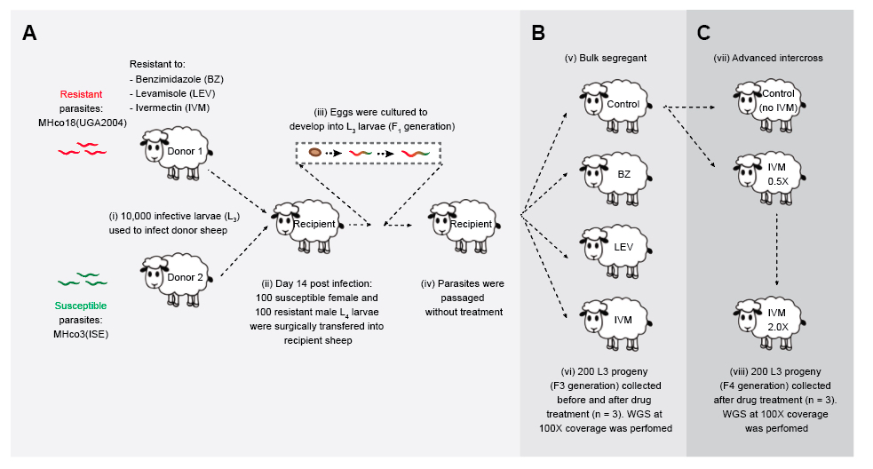

##### Figure 1. Outline of the genetic cross, bulk segregant analysis, and advanced intercross sampling design.

(**A**) A genetic cross between the anthelmintic susceptible MHco3(ISE) and multidrug-resistant MHco18(UGA20014) to map genetic loci associated with each of benzimidazole, levamisole and ivermectin drug classes was performed. (**B**) A drug selection XQTL experiment was performed on the F2 generation, which was split into four groups that were exposed to either (i) benzimidazole, (ii) levamisole, (iii) ivermectin anthelmintic, or (iv) remained untreated. (**C**) An advanced intercross experiment using F3 generation progeny pooled from pre-treated (untreated) were subjected to half- followed by double-standard doses of ivermectin. For both the drug selection XQTL and advanced intercross experiments, pools of L3 (n = 200) were collected both pre- and post-treatment from drug-exposed and time-matched untreated controls. Each experiment was performed in triplicate. Whole-genome sequencing was performed on the pools, after which genetic diversity between pre- and post-treatment was compared.

### 

### Sample preparation and genome sequencing

Genomic DNA was isolated from pools of 200 L3 or individual adult males as follows: 20 μl of 20 mg/μl proteinase K together with 300 μl lysis buffer (200 mM NaCl, 100 mM Tris-HCl, 30 mM EDTA pH 8, 0.5% SDS) was added to the frozen pellets of larvae or adult worms before incubation at 55oC for 2 hours. Next, 10 μl of 10 mg/ml RNAse A was added before incubation at 37 oC for 10 minutes. 550 μl phenol/chloroform/isoamyl alcohol (25:24:1) was added to the lysate, which was then shaken vigorously for 15 seconds, incubated at room temperature for 5 minutes, then centrifuged at 14,000 g for 15 minutes at room temperature. The top layer was carefully removed to a fresh tube and 0.1× volume sodium acetate pH 5.5 was added, followed by 3× volume 100% EtOH at room temperature, then 2 μl glycogen, before overnight incubation at -80oC. After 5 minutes centrifugation at 14,000 g at 4oC, the supernatant was carefully aspirated and 500 μl 70% EtOH was added to the pellet before another 5 minute centrifugation at 14,000 g at 4 oC. The supernatant was carefully removed over a lightbox to visualise the pellet before a brief spin to facilitate aspiration of any remaining EtOH. The pellet was then air-dried until all traces of EtOH were removed, before re-suspending in ≥10 μl EB buffer. Genomic DNA was stored at 4 oC.

Individual sequencing libraries (mean length of ~400 bp) were prepared using a PCR-free protocol as previously described [(Kozarewa et al., 2009)](https://paperpile.com/c/9r14Dh/hebB), and sequenced on an Illumina HiSeq4000 platform using 125-bp PE chemistry. We aimed to perform sufficient sequencing to achieve 100-fold coverage of the ~283 Mb genome for each sample sequenced.

### Mapping and variant calling

Raw sequence data were first assessed for quality using Fastqc (<http://www.bioinformatics.babraham.ac.uk/projects/fastqc/>) and visualised using MultiQC [(Ewels et al., 2016)](https://paperpile.com/c/9r14Dh/m6U2). Reads were first trimmed using trimmomatic v0.32 [(Bolger et al., 2014)](https://paperpile.com/c/9r14Dh/pgIO) before they were mapped to the *H. contortus* V4 reference genome ([(Doyle et al., 2020)](https://paperpile.com/c/9r14Dh/jJX0), available here: <https://parasite.wormbase.org/Haemonchus_contortus_prjeb506/Info/Index/>) using BWA-MEM (bwa: v0.7.12-r1039; [(Li, 2013)](https://paperpile.com/c/9r14Dh/8GR2))(parameters: -Y -C -M). Duplicate reads were marked using Picard (v2.5.0; <https://github.com/broadinstitute/picard>), after which perfectly mapped paired reads were extracted using samtools-1.3 view (-f 14). Finally, indel realignment was performed using GATK v3.7.0 IndelRealigner [(McKenna et al., 2010)](https://paperpile.com/c/9r14Dh/pSUb).

Genetic variation was determined using samtools-1.3 mpileup (parameters: -F 0.25 -d 500 - b bamlist), which was performed for experimental groups of samples (i.e., treatment groups including all replicates).

To determine the predicted functional consequences of individual variants, variants in the mpileup were processed using bcftools v1.9 (parameters: call -vm -Oz), after which annotation of the resulting vcf was performed using SNPeff [(Cingolani et al., 2012)](https://paperpile.com/c/9r14Dh/0TBH) (parameters: -no-intergenic -no-downstream -no-upstream). The current annotation used to build the annotation database is available at WormBase Parasite (release 15).

### 

### Genome-wide analysis of genetic variation

To determine within sample measures of nucleotide diversity, multisample mpileups were first processed to generate a single pileup file per sample, which were subsequently used as input to npstat (parameters: -n 400 -l 5000 -mincov 20 -maxcov 200 -minqual 20 -nolowfreq 2)[(Ferretti et al., 2013)](https://paperpile.com/c/9r14Dh/n5Cu).

Between sample measures of genetic diversity was determined using Popoolation2 [(Kofler et al., 2011)](https://paperpile.com/c/9r14Dh/1EOb); briefly, a syncronised file was first generated from each mpileup (popoolation2 mpileup2sync.jar --min-qual 20). Pairwise estimates of genetic differentiation was first determined by Fst calculated in 5 kbp windows throughout the genome (popoolation2 fst-sliding.pl --pool-size 200 --window-size 1000 --step-size 500 --min-count 4 --min-coverage 50 --max-coverage 2%), and secondly using a Fisher’s exact test on individual variants (popoolation2 fst-sliding.pl --window-size 5000 --step-size 5000 --min-count 4 --min-coverage 30 --max-coverage 2%). Finally, a Cochran-Mantel-Haenszel test (CMH) test of independence to determine concordance of replicate samples per variable site (popoolation2 cmh-test.pl --min-count 2 --min-coverage 30 --max-coverage 2% --population).

* Peak calling
  + Genome-wide level of significance

### Gene-level analyses of variation

Specific variant frequencies were extracted using vcftools v0.1.16 [(Danecek et al., 2011)](https://paperpile.com/c/9r14Dh/drNS).

Analysis of *acr-8* sequence conservation among clade V nematodes was performed by aligning protein sequences obtained from WormBase Parasite using mafft v7.407 [(Katoh and Standley, 2013)](https://paperpile.com/c/9r14Dh/t5eh) and visualised using the ggmsa (<https://cran.r-project.org/web/packages/ggmsa/vignettes/ggmsa.html>) R package.

Protein structure….

### 

### 

### RNAseq analyses

* Refer to Roz’s paper

### Other analyses?

### C. elegans?

### Data availability

Raw sequencing data for this study are outlined in **Table SX** and are archived under the ENA study accession PRJEB4207.

The code used to generate and analyse data and to reproduce figures can be found at <https://github.com/stephenrdoyle/hcontortus_xqtl>.

## 

## Results

### A genetic cross between genetically diverse parental strains reveals distinct loci associated with resistance to each drug class

We identified 16,794,366 variants in the two parental strains of the cross, representing mean nucleotide diversities of 0.021 ± 0.013 SD and 0.027 ± 0.015 SD for MHco3(ISE) and MHco18(UGA), respectively. The high degree of within strain diversity is evident when the two strains are compared, demonstrating broad-scale genome-wide genetic divergence (**Figure 2 A**); with a mean Fst of 0.089 ± 0.066 SD, we identify XXX regions of high genetic differentiation above the genome-wide level of significance (genome-wide mean Fst plus three standard deviations).

Whole-genome comparison of pre- and post-treatment samples at the F2 generation of the cross aims to identify discrete regions of high genetic differentiation due to the loss of susceptible alleles and retention of resistant alleles post-treatment; regions of the genome not associated with resistance will remain an admixture of background genetic variation from the two parental strains and, therefore, low genetic differentiation between before and after drug treatment samples is expected. Comparison of a no-treatment control demonstrates the extent of admixture after crossing the two diverse parental strains, and the low genetic differentiation between time-matched sampling in the absence of drug (**Figure 2 B: Control**). In contrast, for each the drug treatment conditions, we identified discrete regions of genetic differentiation that differed between each drug class; after benzimidazole treatment, we identify a major peak on chromosome 1 (**Figure 2 B: Benzimidazole**), after levamisole, two major peaks on chromosome 4 and 5 (**Figure 2 B: Levamisole**), and after ivermectin, a major peak on chromosome 5 and minor peaks on chromosomes 2 and 5 (**Figure 2 B: Ivermectin**). The peak coordinates are defined in **Table S2**, however, the main genetic associations with each drug class will be discussed in more detail below.

To complement the genetic cross and XQTL datasets, we sampled pools of L3 from 10 farm field populations in the US. These farms have applied different management strategies and have different drug exposure histories, and thus, the worms have been exposed to and have been under different drug selection pressure(s). While we do not have comprehensive detail of the management history of these populations, we have determined the drug resistance phenotype (EC50 concentration) of the populations using a larval development assay (DrenchRiteⓇ Assay; REFERENCE) in the presence of each of the three drug classes analysed (see **Table S3** for EC50 data for the three drug classes); farms were selected for comparative analysis based on these data, from which two ivermectin susceptible, three moderately resistant and five highly resistant farm populations to ivermectin were chosen (**Figures S1 and S2**). These farms also have variable levels of both benzimidazole and levamisole resistance, which together with ivermectin, were used to cross-validate candidate regions and variants identified in the XQTL with resistance based on genetic variation selected for in the field.

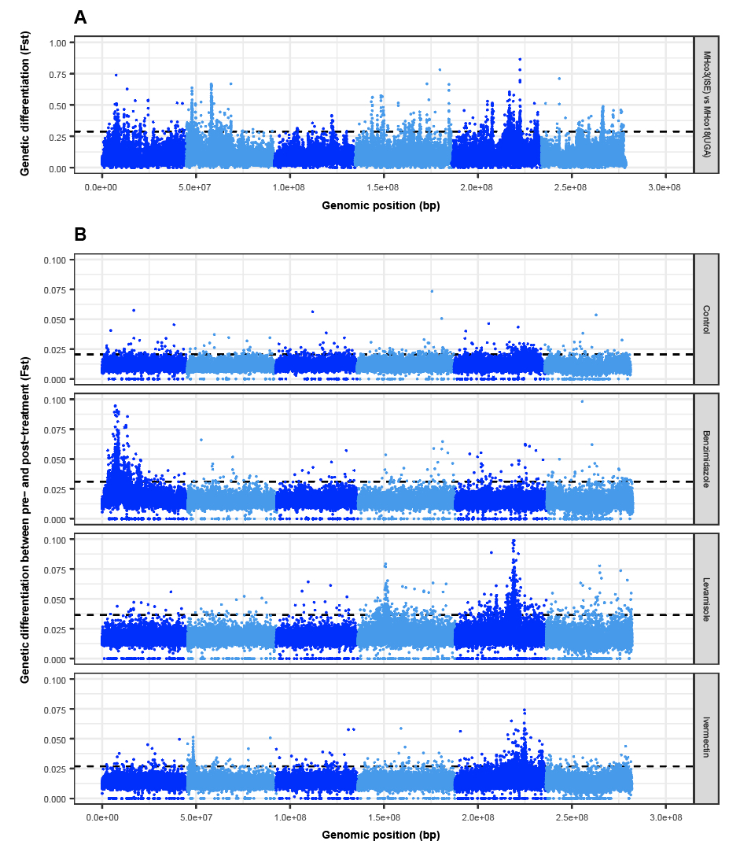

##### Figure 2. Genome-wide analysis of genetic diversity of parental strains and F3 generation of the genetic cross before and after drug treatment.

**A.** Genome-wide comparison of susceptible MHco3(ISE) and multidrug-resistant MHco18(UGA2004) parental strains reveals broad-scale genetic differentiation on all chromosomes. **B.** Comparison of genome-wide differentiation between F3 generation pooled L3 (n = 200) sampled pre- and post-treatment (F2 generation adults) reveals distinct genomic regions associated with benzimidazole, levamisole, and ivermectin drug treatment. A untreated control whereby sampling was time-matched to the treated groups is included for comparison. Three biological replicates were performed. In each plot, the genome-wide level of significance is indicated by the dashed line and represents the mean + 3 SD of the genome-wide Fst for each comparison.

#### 

#### 

#### XQTL: Benzimidazole analysis

A single broad peak was identified on chromosome 1 after selection with benzimidazole, with little evidence of selection occurring on other regions throughout the genome; focusing on this single region, three statistically defined “sub-peaks” were identified (Figure 3 A; Table SX). The first peak (position XXX) contains the β-tubulin isotype 1 (HCON_00005260) locus, a gene in which three variants - Phe167Tyr, Ala198Glu, and Phe200Tyr - have broadly been associated with benzimidazole resistance in *H. contortus* [(Kwa et al., 1994)](https://paperpile.com/c/9r14Dh/NTUJ) and other nematodes frequently exposed to benzimidazole treatment (REFERENCES). We identified a small but non-significant increase in allele frequency at the Phe167Tyr position (mean *freq*(pre-treatment) = 0.14 to *freq*(post-treatment) = 0.20; *P* = 0.133) and an absence of the Ala198Glu variant. However, we identified a significant increase in the Phe200Tyr variant frequency from pre- to post-treatment and relative to untreated controls (**Figure 3 B;** *P* = 0.019); considering the previous association between this variant and benzimidazole resistance (REFS), we propose this variant is the likely driver of phenotypic resistance in the XQTL population. Note that this variant, despite being the likely driver of resistance, was not the most significantly differentiated variant between pre- and post-treatment in the region; 817 variants including 8 non-synonymous variants were identified on chromosome 1 with a p-value equal or lower than the variant at Phe200Tyr (*P* = 1.747e-26; genome-wide Cochran–Mantel–Haenszel (CMH) test between replicates), highlighting one of the challenges of correctly identifying causative mutations even under the controlled conditions of the genetic cross. The presence of the additional two peaks downstream of the peak containing β-tubulin isotype 1 locus is less clear. While the peak surrounding the β-tubulin isotype 1 locus is present in the US farms that are phenotypically resistant to benzimidazoles, the additional downstream peaks are absent. These additional peaks may, therefore, reflect an artefact of the cross due to the linkage disequilibrium with the Phe200Tyr mutation, although recombination rate variation in this region (derived from the same genetic cross; see [(Doyle et al., 2018)](https://paperpile.com/c/9r14Dh/OlG8)) suggests that this is unlikely. Alternatively, these peaks may represent selection on additional, novel loci that require further investigation. For example, it is curious that 2 of the 8 non-synonymous variants lie in cathepsin B-like cysteine proteinases (HCON_00005790 & HCON_00005960), which have previously been implicated in benzimidazole-mediated damage of intestinal cells of *H. contortus* [(Jasmer et al., 2000; Shompole and Jasmer, 2001)](https://paperpile.com/c/9r14Dh/mcSw+Wwib).

*H. contortus* has multiple β-tubulin genes [(Saunders et al., 2013)](https://paperpile.com/c/9r14Dh/r2QK) and deletion of the β-tubulin isotype 2 gene (HCON_00043670) on chromosome 2 has been associated with increased levels of resistance beyond that of mutations in the isotype 1 gene alone [(Kwa et al., 1993)](https://paperpile.com/c/9r14Dh/jIxi). Here, we find no evidence of deletions in isotype 2, however, a minor but not significant peak and the presence of a Glu198Val variant is present at low frequency. On the US farms, however, the Glu198Val variant (position 13435822/3; GGA > TTA) does increase in frequency and shows a significant correlation (r = 0.979, *P* = 4.31e-6; Pearson’s correlation) with DrenchRite EC50 values for benzimidazole resistance (**Figure 3 C**). The variance observed in EC50 concentration between farm populations is not caused by variance in the Phe200Tyr mutation of the isotype 1 gene, as this variant is already at high frequency in these populations (**Figure S3**). These data suggest that once the isotype 1 Phe200Tyr mutation has reached near fixation in the population, the Glu198Val of isotype 2 mediates higher levels of benzimidazole resistance than conferred by Phe200Tyr variant alone in response to persistent drug exposure. The broader significance of the Glu198Val variant is not clear; in the global diversity data [(Sallé et al., 2019)](https://paperpile.com/c/9r14Dh/bkpG), we do not find evidence of selection at the position in populations outside of the US, however, we do find a high frequency of an isotype 2 Phe200Tyr variant in a known benzimidazole-resistant population (Guadeloupe; n = 12, *freq*(Phe200Tyr) = 0.83). These results suggest that variation in isotype 2 should be considered in addition to the well-characterised isotype 1 variants as a genetic diagnostic for benzimidazole resistance.

Finally, although the β-tubulin isotype 1 Phe200Tyr variant is widely accepted as being associated with benzimidazole resistance, there has been a suggestion of a genetic association between the Phe200Tyr variant and ivermectin resistance in *H. contortus* [(Eng et al., 2006; de Lourdes Mottier and Prichard, 2008; Santos et al., 2017)](https://paperpile.com/c/9r14Dh/GzRv+eN7t+mT1U) and the filarial nematode *Onchocerca volvulus* [(Osei-Atweneboana et al., 2012)](https://paperpile.com/c/9r14Dh/JZj3). We, however, find no evidence of selection on either the Phe167Tyr or Phe200Tyr variants (or any variant found in the region) in the pre-vs-post ivermectin-treated XQTL analyses ([**Figure S4 A**](https://docs.google.com/document/d/1o2tyNAmLu0RGS2X5S5kwtFxb_7c6KIo1VBVzEi5IAEw/edit#heading=h.u7i9lnat3pl)), nor any correlation with DrenchRite-defined ivermectin EC50 on the US farms (**Figure S4 B**).

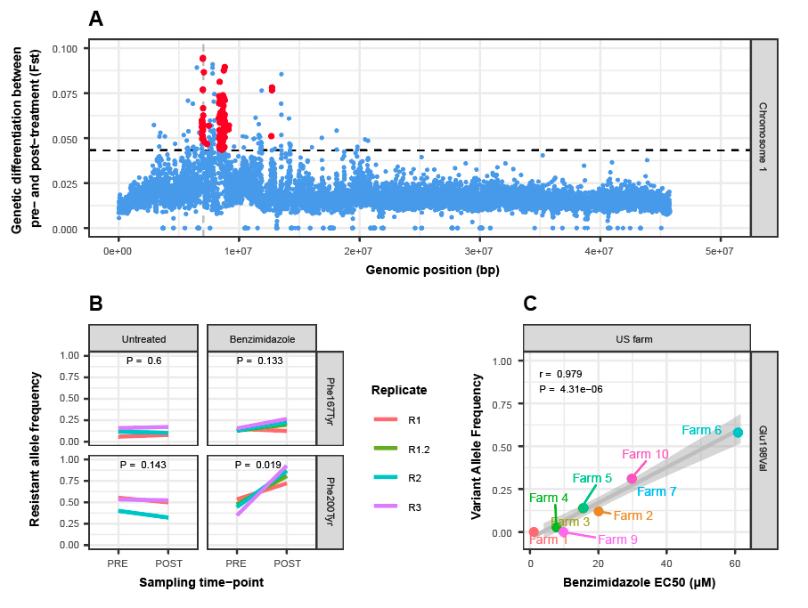

##### Figure 3 - Benzimidazole selection

**A.** Focus on the major peak of chromosome 1 between pre- and post benzimidazole treatment chromosome-wide genetic differentiation. Genome-wide level of significance is indicated by the dashed line (mean + 3 SD of the chromosome-wide Fst). Each point represents a 5 kbp window; the red points… XXXX. **B.** Allele frequency change at Phe167Tyr and Phe200Tyr variant positions of β-tubulin isotype 1 (HCON_00005260) pre- and post-treatment, including untreated time-matched control. Biological replicates are shown. P-values were calculated using a pairwise t-test of allele frequency by time point. **C.** Correlation between benzimidazole EC50 concentration (μM) and Glu198Val variant frequency of β-tubulin isotype 2 (HCON_00043670) on US farms. Pearson’s correlation (r) and associated p-value are shown.

#### XQTL: Levamisole analysis

Levamisole resistance is typically associated with variation in acetylcholine receptor subunits or components that contribute to acetylcholine-mediated signalling [(Fleming et al., 1997)](https://paperpile.com/c/9r14Dh/05cV); we identified two major peaks of genetic differentiation on chromosome 4 and 5, each containing a tandem duplication of the acetylcholine receptor subunit beta-type *lev-1* (HCON_00107690 & HCON_00107700) and acetylcholine receptor subunit *acr-8* (HCON_00151270), respectively (**Figure 4 A**).

The identification of *lev-1* genes within the chromosome 4 peak is compelling and two synonymous variants at positions 14995062 (*P* = 1.658e-20; CMH test) and 15053946 (*P* = 4.620e-21; CMH test) in HCON_00107700 were among the most differentiated SNPs in this region; however, we found no high effect mutations and, although multiple non-synonymous variants were identified (7 and 3 variants for HCON_00107690 and HCON_00107700, respectively), only relatively minor shifts in allele frequency were seen upon levamisole treatment. In *C. elegans*, despite several dominant resistant variants characterised (note these were not found in the data described here), *lev-1* can be lost without affecting the function of the receptor [(Fleming et al., 1997)](https://paperpile.com/c/9r14Dh/05cV). It is, therefore, unclear to what effect the variation in *H. contortus* *lev-1* subunits we observe has toward levamisole resistance. Close to the *lev-1* loci and toward the centre of the peak of differentiation, 5 of the top 12 variants in chromosome 4 including 2 synonymous, 2 intronic, and a single non-synonymous variant (Arg934His at position 14781344; *P* = 1.015e-21; CMH test) were found in HCON_00107560, an ortholog of *C. elegans* *kdins-1*. Highly conserved with mammalian orthologs [(Kong et al., 2001)](https://paperpile.com/c/9r14Dh/EXg2), it has been shown to colocalise with acetylcholine receptors at rat neuromuscular junctions during development [(Luo et al., 2005)](https://paperpile.com/c/9r14Dh/Ojo6) where, via a PDZ domain, participates in the coordination of signalling components including ion channels and neurotransmitters. The precise role of HCON_00107560 or *kdin-1* in *H. contortus* or *C. elegans*, respectively, remains unknown, however, its putative association with levamisole response here warrants further investigation.

The acetylcholine receptor subunit *acr-8* (**Figure 4 B**) has long been implicated in levamisole resistance; a truncated isoform of *acr-8* containing the two first exons and a part of intron 2 (previously called *Hco-acr-8b*) was originally identified in a cDNA screen of resistant parasites [(Fauvin et al., 2010)](https://paperpile.com/c/9r14Dh/Aos9), and subsequently, a 63 bp indel between exons 2 and 3 was proposed to be associated with resistance based on its presence in several resistant isolates [(Barrère et al., 2014)](https://paperpile.com/c/9r14Dh/OfjS). Here, we identify two slightly larger deletion variants spanning 31,527,022 to 31,527,119 (97 bp) or 31,527,121 (99 bp) that increase in frequency after levamisole treatment (**Figure 4 C,** from 81.52% to 90.71% of sequencing reads containing the deletion pre- to post-treatment, respectively, based on read coverage within and outside of the indel). In the same region, the deletion also lies within the intron of a second gene encoding a cuticle collagen (HCON_00151260) found on the opposite strand to *acr-8*. Although truncated *acr-8* has been correlated with resistance in several studies and therefore previously proposed as a viable genetic marker of levamisole resistance [(Barrère et al., 2014; Santos et al., 2019)](https://paperpile.com/c/9r14Dh/OfjS+g1eD), the functional consequence of the indel towards mediating levamisole resistance *in vivo* is not yet clear. Despite the increase in frequency of the deletion after treatment, the *acr-8* indel is present in the levamisole susceptible parental MHco3(ISE) strain (59.05%) and is present only at a slightly higher in frequency in the resistant MHco18(UGA) strain (63.55%). Further, no genetic variants segregate in the XQTL datasets that could obviously explain the aberrant splicing to generate the truncated form. Thus, we argue that further transcriptional and *in vivo* functional evidence is needed to validate the precision of this indel as a marker and mediator of levamisole resistance.

We have, however, identified a nonsynonymous variant at position 31521884 (Ser168Thr) in *acr-8* that is strongly correlated with resistance across multiple datasets. In the XQTL analysis, Ser168Thr increases to high frequency after drug selection in the F2 generation (**Figure 4 D**; genome-wide CMH: *P* = 1.645e-15; allele frequency change pre- vs post-treatment: *P* = 0.0001; relative to time-matched no-treatment control: *P* = 0.4), and is found at a moderately high frequency in the US field population with the highest levamisole drug resistance (Farm 7; *freq*(Ser168Thr) = 0.64). Further, using global diversity data [(Sallé et al., 2019)](https://paperpile.com/c/9r14Dh/bkpG), we find the variant fixed in samples from the Kokstad (KOK) population (*freq*(Ser168Thr) = 1.0; n = 4), the only population with confirmed levamisole resistance, whereas the variant is absent in all other populations analysed. We note that an equivalent non-synonymous variant in the same position relative to the sequence alignment is found at high frequency in levamisole resistant *Teladorsagia circumcincta* (Cont419:G75849G at position Ser140Thr), which is absent in the susceptible population to which it was compared [(Choi et al., 2017)](https://paperpile.com/c/9r14Dh/9nbY). Although a serine to threonine variant is expected to be a relatively conservative change in amino acid chemistry, the serine residue is highly conserved among clade V nematodes ([**Figure S**](https://docs.google.com/document/d/1o2tyNAmLu0RGS2X5S5kwtFxb_7c6KIo1VBVzEi5IAEw/edit#heading=h.lg8xtzue8y2v)**6**); its position in *acr-8*, immediately downstream of the cys-loop, is within the ligand-binding pocket and is immediately adjacent to a highly conserved tryptophan residue that has been shown to essential for ligand binding [(Lynagh and Pless, 2014; Williams et al., 2009)](https://paperpile.com/c/9r14Dh/W7FJ+i63y) (**Figure 4 E**). Key residues downstream of the conserved tryptophan residue of closely related receptor subunits have been shown previously to influence levamisole sensitivity [(Rayes et al., 2004)](https://paperpile.com/c/9r14Dh/7jKi); thus, we hypothesise the Ser168Thr variant may facilitate a necessary and sufficient change in the molecular interactions within the binding pocket of *acr-8* that results in a decreased sensitivity to levamisole and requires further validation.

Signals of selection on two components of the pentameric acetylcholine receptor prompted us to look for selection on the remaining subunits. Although the expression of *unc-63* (HCON_00024380) and *unc-29.3* (HCON_00003520) mRNAs was significantly reduced in the resistant larvae of this resistant strain [(Williamson et al., 2011)](https://paperpile.com/c/9r14Dh/iouV), no evidence of direct selection on the region of the genome containing these genes was found suggesting that selection may be on upstream regulation of these components.

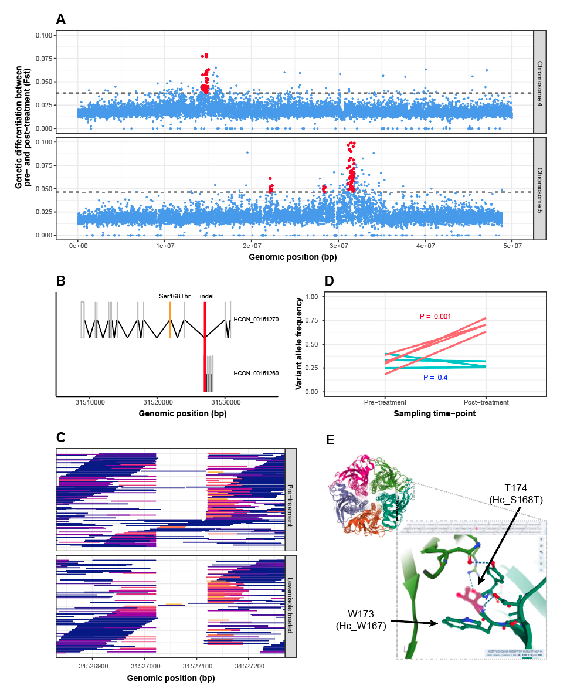

##### Figure 4. Levamisole selection

**A.** Peaks of genetic differentiation between pre-treatment and levamisole treated parasites on chromosome 4 (top) and chromosome 5 (bottom). **B.** Gene model for *acr-8* (HCON_00151270) and a cuticle collagen (HCON_00151260) highlighting the position of the *acr-8*/levamisole-associated indel in the intron between exon 2 and exon 3 (and exon 1 and 2 of HCON_00151260), and the Ser168Thr variant on exon 4 of *acr-8*. **C.** Visualisation of sequencing reads supporting the *acr-8* intronic indel, comparing the number of reads that either align across (i.e. no deletion) or are “soft clipped” due to the deletion between pre-treatment and post-treatment samples. Reads are coloured to reflect the degree that they are clipped, i.e. reads with no clipping / full length mapped reads are blue, whereas reads that are moderate to highly clipped to map correctly are coloured red to yellow, respectively. **D.** Comparison of Ser168Thr variant frequency between pre- and post-levamisole treatment (red), and in time-matched untreated controls (green). **E**. The acetylcholine receptor is an example of a pentameric cys-loop receptor. Shown is the molecular structure of XXX, one of the few crystal structures where the receptor has been resolved. The Ser168Thr variant of *acr-8* lies within the acetylcholine binding pocket at the interface of XXXX and immediately adjacent to W167, a residue previously characterised to be essential for ligand binding.

#### XQTL: Ivermectin analysis

Many genes have associated with ivermectin resistance in parasitic worms, largely conferred either via shared orthology of genes conferring resistance in *C. elegans*, or by comparison of genetic variation and/or gene expression of candidate genes in parasite isolates that differ in their response to ivermectin. We have previously identified a major QTL from 37 to 42 Mbp on chromosome 5 associated with ivermectin resistance from the analysis of a backcross experiment performed using in two genetically and geographically diverse ivermectin resistant *H. contortus* strains [(Doyle et al. 2019; Redman et al. 2012)](https://paperpile.com/c/9r14Dh/r6yC+ZKe6). While this ~5 Mbp region identified was broad and contained many genes, largely due to limited resolution as a result of the crossing strategy and low recombination in the region, the genetic signature was consistent with a single dominant driver variant; importantly, this analysis was able to exclude most of the candidate genes previously proposed.

Here, we identify with increased resolution the major chromosome 5 peak at ~37.5 Mbp, a second albeit less prominent peak of differentiation at ~46 Mbp also on chromosome 5, and a third peak at ~3 Mbp on chromosome 2 (**Figure 5A**). The second chromosome 5 peak was also identified as a candidate region associated with resistance in the backcross analyses [(Doyle et al., 2019a)](https://paperpile.com/c/9r14Dh/r6yC), however, we did not have the statistical power to differentiate it from the main peak previously identified; here, it appears to segregate independently of the main 37.5 Mbp peak, providing stronger evidence of a secondary resistance-conferring variant on chromosome 5. The major peak is now resolved to XXX kb, based on high Fst (**Figure 5B**), and the negative correlation between loss of nucleotide diversity and the increase in EC50 ivermectin resistance phenotype on US farms (**Figure 5C**). Similarly, this was the only region in which a dose response correlation was observed between ivermectin resistance and degree of genetic differentiation between susceptible and moderate or high resistance field populations (**Figures S1 and S2**). As with the previous analysis, we have not identified a clear causative gene or variant driving resistance, however, we have reduced the number of candidate genes significantly (from ~360 to ~20). A number of the genes in the region are identified as an expansion of protein kinases (13 genes present of 19 in the genome with InterPro ID IPR015897: Zinc finger C4 and HLH domain containing kinases domain subfamily of choline kinases), some of which have the highest statistical association with resistance based on genetic differentiation between pre- and post-treatment (for example,HCON_00155150 [pos. 37235924, *P* = 7.070e-13; pos. 37235944, *P* = 1.244e-12] and HCON_00155230 [pos. 37319896, *P* = 9.769e-11]). The lack of additional functional information, no previous association with resistance, and difficulty in associating 1-to-1 orthology with *C. elegans* genes due to the *H. contortus*-specific expansion of the gene family makes it difficult to further infer any role towards ivermectin resistance. Towards the centre of the peak, we identify *cky-1* (HCON_00155390; pos. 37487982 - 37497398), an ortholog of the transcription factor NPAS4 that is associated with controlling activation-dependent excitation/inhibition balance at neuromuscular junctions and limiting excitotoxicity in mammals, with 8 moderately to highly differentiated non-synonymous variants (top variant: pos. 37497061 [Ser583Pro], *P* = 1.353e-09; CMH test). Analysis of RNAseq-assayed gene expression shows *cky-1* as one of the only genes in the region to be significantly upregulated in both the resistant MHco18(UGA2004) parent and surviving F2 generation adults post-treatment relative to the susceptible MHco3(ISE) parent (**Figure 5 D**), which is further validated by RT-qPCR in two unrelated resistant *H. contortus* strains (**Figure 5 E**). To explore *cky-1* further, we used *C. elegans* larval development assays to test the role of over and underexpression on the development of the resistant phenotype. While complete knockout of *cky-1* is unviable, analysis of a balanced deletion variant did result in increased susceptibility to ivermectin (**Figure 5 F**). However, attempts to over-express *cky-1*, as we observed in the resistant *H. contortus* strains, did not increase resistance to ivermectin under the conditions tested. These data suggest that *cky-1* overexpression is associated with and may contribute to the ivermectin resistance phenotype in *H. contortus*, however, further validation is needed to confirm this hypothesis.

The minor peak on chromosome 5 (range: XXX) contains XXX genes, including two genes *avr-15* (HCON_00161180) and *pgp-11* (HCON_00162780), both of which have been associated with ivermectin resistance in many nematode species (REFS). Here, both genes lie on the boundaries of the peak, and while they do contain statistically significant non-synonymous variants (3 and 5 for *avr-15* and *pgp-11*, respectively), they are relatively minor differences in variant frequency between pre- and post-treatment (relative to other variants within the region) leading us to conclude that they are unlikely to be the direct target of selection here.

Finally, the minor peak towards the start of chromosome 2 (region: 2992500-3267500) contains two previously described candidate genes - *osm-1* (HCON_00035760) and *che-11* (HCON_00035880) - that have been shown to confer resistance either directly [(Page, 2018)](https://paperpile.com/c/9r14Dh/5EF1) or additively with other variants [(Dent et al., 2000)](https://paperpile.com/c/9r14Dh/tvTc) in *C. elegans*. Neither gene contained high effect variants, however, both contained a number of non-synonymous variants, including 3/12 moderately differentiated variants between pre- and post-treatment in *osm-1* (pos. 3109316 [Gln1540Pro], *P* = 8.444e-05; pos. 3109310 [Val1542Gly], *P* = 8.337e-06; pos. 3109002 [Glu1577Asp], *P* = 4.936e-04) and 4/17 variants with significant but less differentiated variants in *che-11*. A glutamate transporter family protein *glt-5* ([HCON_00035710](https://parasite.wormbase.org/haemonchus_contortus_prjeb506/Gene/Summary?g=HCON_00035710)) was also identified, however, there was no evidence of selection at this locus.

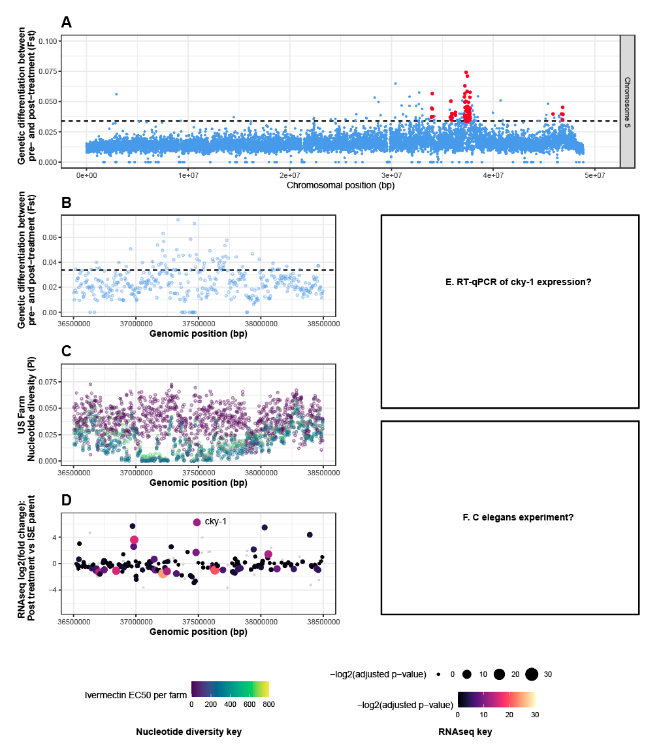

##### Figure 5. Ivermectin selection

**A.** Peaks of genetic differentiation between pre- and post-ivermectin treatment on chromosome 5. **B,C,D.** A magnified aspect of the main chromosome 5 peak, highlighting genetic differentiation (Fst) (**B**), nucleotide diversity on US farms, where each farm is coloured by the degree of ivermectin resistance (EC50) measured by larval development assay (**C**), and differential expression (log2[fold change]) between post-treatment and the MHco3(ISE) parental strain measured using RNAseq (**D**), where the size and colour of each point (representing a gene) represents the -log2(adjusted p-value). *Cky-1*, which lies toward the middle of the peak and has the highest differential expression of genes in the peak, is shown. In panels **A** and **B**, the genome-wide level of significance is indicated by the horizontal dashed line and represents the mean + 3 SD of the genome-wide Fst for each comparison.

E. validation of cky-1 expression in other resistant isolates

F. c. elegans experiment?

### 

### Ivermectin resistance mediated by the chromosome 5 locus is consistent between indirect and direct modes of selection

The analyses presented have been performed on the progeny (environmentally accessible eggs from faeces developed to L3 in culture) of adult parasites that were directly exposed to anthelmintics *in vivo*. Therefore, measures of selection on genetic diversity have been indirect; as the progeny sampled are not directly exposed to the treatment, this approach assumes that the genetic variation sampled in the progeny is a direct reflection of the variation in the adults directly exposed to treatment *in vivo*. While we know this to be largely true, given that the mode of inheritance of ivermectin resistance is likely dominant or semi-dominant (F1 individuals are ivermectin resistant, consistent with other *H. contortus* strains that share the dominant chromosome 5 signature of selection [(Doyle et al., 2019a; Le Jambre et al., 2000)](https://paperpile.com/c/9r14Dh/dpYU+r6yC)), mating between phenotypically-resistant heterozygous adults will produce ~25% phenotypically susceptible homozygous progeny; the consequence of this is a reduction in both (i) the overall frequency of the resistant allele in the post-treatment progeny populations, and (ii) the genetic differentiation between pre- and post-treatment populations, i.e. the causative resistant allele will not go to fixation in the surviving, post-treatment progeny population due to the presence of phenotypically susceptible individuals. To address this, we performed two additional complementary experiments to test the effect of direct selection. First, we sequenced pools of F3 adult male worms that have survived treatment and compared them against pooled control L3 from the same generation; the genome-wide diversity was generally more variable (**Figure S6 A**), perhaps due to the lower number of individuals sampled (n = 40 adult males) and the comparison between single-sex adults and mixed-sex L3, however, the chromosome 5 region was still discernable with the peak of differentiation between 37.3 and 37.5 Mbp (**Figure S6 B**). Second, we performed a larval development assay on the F5 generation of the cross; eggs were collected and plated *in vitro*, and emerging larvae were allowed to develop in the presence of the ivermectin. We first performed a dose-response experiment to determine the EC50 concentration of the population (**Figure S6 C;** EC50 = XXX), followed by a second bulk selection at EC25 and EC75. Two groups of larvae were obtained and compared by whole genome sequencing: (i) those that were susceptible to the drug at the EC25 concentration of ivermectin treatment and began to developmentally arrest at L1/L2 stages, and (ii) those that were resistant to the drug and proceeded to develop to L3 stage at EC75. Here, a clear peak at the chromosome 5 locus with comparatively little background variation was observed between the two groups (**Figure S6 D**). These additional experiments both provide evidence to support the importance of the chromosome 5 locus toward ivermectin resistance, and that this signal of selection is consistent in assays that directly and indirectly sample genetic variation after drug exposure.

### Half-dose followed by double-dose ivermectin treatment primes selection at novel loci

Finally, we attempted to identify genetic variants that would confer high levels of resistance by first treating with a half-standard dose (0.1 mg/kg), followed by a subsequent double-standard dose treatment (0.4 mg/kg) XXX days later. This is in contrast to the standard treatment dosage of 0.2 mg/kg applied throughout the XQTL experiments. Larvae were sampled pre- and post-treatment as before (pools of 200 L3), and included a time-matched, untreated control. Relative to timed matched controls (**Figure 6 A and B**), at the half standard dose we identified discrete regions of chromosomes 2 and 5 (**Figure 6 C)** that increased in genetic differentiation after the double dose treatment (**Figure 6 D**). After replication, however, different patterns of selection emerged; while the chromosome 5 region of differentiation was consistent between all replicates, we identify replicate-specific peaks in the double standard dose treated population on chromosomes 1 (region: 11047500 - 11292500), 2 (same coordinates as XQTL peak), 3 (region: 38012500 - 38057500), and 4 (region: XXX) (**Figure 6 E, F,** and **G** show biological replicates, with new peaks highlighted by red dashed box). There is also variation that may also be suggestive of selection at additional loci, however, they cannot be statistically differentiated from the high degree of genetic variation throughout the genome in these pooled samples. One hypothesis is that these peaks represent stochastic noise unrelated to drug exposure, evidenced by the fact that they only appear in a single replicate (apart for the chromosome 2 peak that does replicate from the XQTL analyses). Alternatively, these discrete peaks may provide evidence of selection on different genes in different sub-populations that contribute to the resistance phenotype (i.e. additively to provide additional levels of resistance, and/or to compensate for fitness costs associated with variation needed for resistance) together with the necessary and sufficient causative allele on chromosome 5. If the latter is correct, these data emphasizes the role that underdosing (initiated first by half-standard dose treatment) may lead to different signatures of selection in the field.

### 

##### 

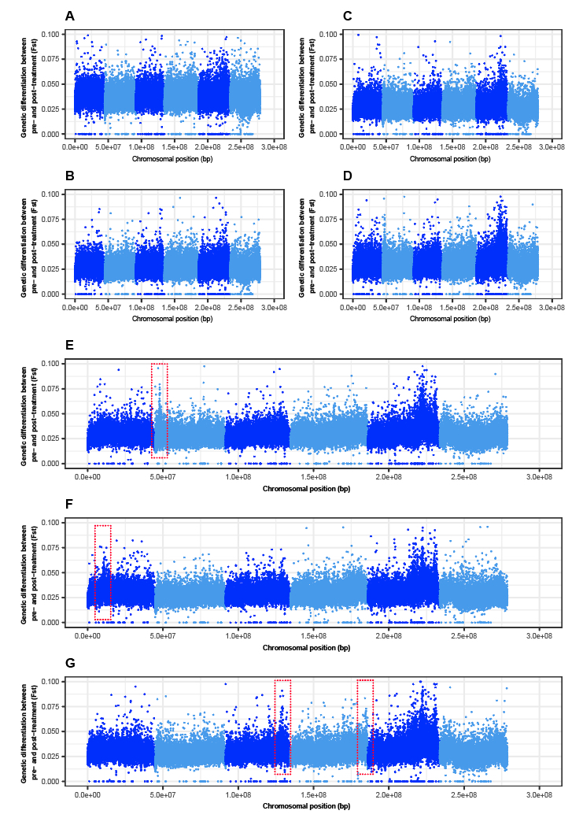

##### Figure 6 - Differential dosing changes the genetic signature of ivermectin treatment

Comparison of untreated, time matched control (**A,B**) and ivermectin treated populations (**C,D**) that were sampled before and after the treated population were exposed to half-dose (**C**) followed by double dose (**D**) standard ivermectin treatment. **E,F,G**. When replicated (each plot shows a replicate), new discrete peaks were identified (indicated by the red dashed boxes) in the double dose treatment comparisons, together with the necessary and sufficient peak of differentiation of chromosome 5.

### 

### 

### 

##### 

## Discussion

Using a genetic cross followed by a series of drug selection experiments, we have demonstrated an efficient approach to map and genetically disconnect multiple drug resistance-conferring loci for three major classes of anthelmintic drugs in *Haemonchus contortus*. Using genome-wide comparisons of parasite populations sampled before and after treatment, we have identified: (i) evidence of selection in discrete regions of the genome and in turn, could discount evidence of selection on many previously proposed candidate genes, (ii) signals of selection around genes and variants previously associated with drug resistance, for example, the β-tubulin isotype 1 Phe200Tyr variant associated with benzimidazole resistance, and the *acr-8* indel variant associated with levamisole resistance, and (iii) novel loci with a strong genetic and statistical association with resistance, including the β-tubulin isotype 2 Glu198Val variant correlated with benzimidazole resistance in field populations, the *acr-8* Ser168Thr variant associated with levamisole resistance in our *H. contortus* cross and field populations and as a candidate resistant marker in the related strongylid *T. circumcincta*, and finally, *cky-1* as a novel candidate mediator of ivermectin response.

A key feature and thus advantage of the genetic cross approach applied here is that the high degree of genetic variation that differentiates the founding susceptible and resistant strains (e.g. **Figure 2A**) is controlled by admixture in the F1 generation; both susceptible and resistant alleles will segregate at moderate frequencies in the absence of selection, and recombination between susceptible and resistant haplotypes will breakdown linked variation that defines the parental strains (e.g. **Figure 2B: Control**). The resolution to map these causal loci is, however, dependent on the amount of recombination that has taken place number and thus population size (as a function of the recombinant individuals possible); although we assayed variation from 200 progeny per pool, our ability to refine the regions was limited to relatively broad regions around a peak of genetic differentiation. This resolution was further confounded by high levels of background (non-causal) genetic variation within the broad peak that is maintained due to linked selection with the causal variant inherited from the founding resistant strain. Increased resolution could be achieved by increasing the sample size per pool (see **Figure S7** for preliminary data using ~5000 L3 progeny per pool), as has been recently demonstrated using *C. elegans* in which millions of individuals were used per pool [(Burga et al., 2019)](https://paperpile.com/c/9r14Dh/t42W). Further resolution towards defining causal loci could be achieved by reducing the genetic variation in the founding cross, either by crossing phenotypically distinct parental strains that are genetically more closely related, or by experimental evolution whereby a resistance phenotype is gradually selected for from a susceptible population using increasing drug exposure over time. We complemented our cross analyses by generating new field-derived data with resistance phenotypes together with a recently published global diversity dataset for *H. contortus* [(Sallé et al., 2019)](https://paperpile.com/c/9r14Dh/bkpG). While the populations from which these data are derived are inherently more genetically diverse, and their management and treatment histories remain largely unknown to us, they provide a useful comparison and validation of loci identified in the crosses, and will be valuable datasets for which future studies will be based and built upon.

While we successfully mapped known and novel loci associated with benzimidazole and levamisole resistance, we made significant effort to resolve the genetic mediators of ivermectin resistance. It is broadly accepted that the mode of action of ivermectin is on ligand-gated channels, of which resistance is best demonstrated by variants in channels gated by glutamate [(Laing et al., 2017)](https://paperpile.com/c/9r14Dh/7j04). High-level resistance-conferring variants in a number of these channels (*glc-1, avr-14* and *avr-15*) in the model free-living nematode *C. elegans* have been characterised [(Dent et al., 2000)](https://paperpile.com/c/9r14Dh/tvTc) and selection on at least one of these channels in wild strains (*glc-1*)[(Ghosh et al., 2012)](https://paperpile.com/c/9r14Dh/MidF) demonstrated, however, there is little evidence here or inconsistent evidence elsewhere to suggest that genetic variation in these channels confers ivermectin resistance in parasitic nematodes including *H. contortus*. Similarly, transcriptional change in these channels in resistant, relative to drug-susceptible, parasite strain are also associated with mediating resistance, for example, in the original description of the resistant MHco18(UGA) strain used here [(Williamson et al., 2011)](https://paperpile.com/c/9r14Dh/iouV), where

increased expression of glutamate-gated chloride channel subunits (*glc-3, glc-5*), as well as p-glycoprotein ABC transporters (*pgp-1, pgp-2, pgp-9*), were described. However, none of these genes were found in regions of differentiation after treatment, suggesting these are not the direct target of selection but may be a downstream response to selection on a regulator of this transcriptional response. We recently identified a major locus associated with ivermectin resistance, mapped to within ~5 Mb on chromosome 5 [(Doyle et al., 2019a)](https://paperpile.com/c/9r14Dh/r6yC); here we resolved the region to ~250 kbp, which contains XXX annotated genes. None of these genes constitutes a previously described candidate gene associated with ivermectin resistance; this both highlights the limitation of candidate gene approaches, and the power of genome-wide approaches to identify novel mediators of resistance [(Doyle and Cotton, 2019)](https://paperpile.com/c/9r14Dh/2jKi).

Our proposed candidate in the main peak of differentiation on chromosome 5 is the NPAS4 ortholog *cky-1*, an activity-dependent basic Helix-Loop-Helix (bHLH)-PAS family transcription factor that has been shown in mammals to regulate the excitation/inhibition balance upon neuronal activation [(Spiegel et al., 2014)](https://paperpile.com/c/9r14Dh/7m5c) to limit excitotoxicity and during the development of inhibitory synapses to control the expression of activity-dependent genes [(Lin et al., 2008)](https://paperpile.com/c/9r14Dh/0y1U); it is yet to be determined if this is a conserved molecular function in nematodes, however, it is tempting to speculate that the hyperexcitability as a result of induced activation of ion channels by ivermectin at the neuromuscular junction is, at least in part, controlled by a “retuning” of the excitation/inhibition balance to limit toxicity. Here, the putative role of *cky-1* towards ivermectin resistance is supported by (i) consistent genome-wide patterns of selection around this locus between experiments presented here that is replicated in geographically and genetically diverse strains elsewhere, (ii) the presence of non-synonymous variants that are highly differentiated before and after treatment (iii) increased gene expression in resistant strains relative to susceptible strains, and (iv) knockdown of the *C. elegans* ortholog leads to hypersensitivity to ivermectin. We emphasise that overexpression of *cky-1* in *C. elegans* did not recapitulate the resistance phenotype; while this may provide support against *cky-1* as a mediator of resistance, it may also reflect the challenge of using a heterologous expression system in which there is an assumption that the biology is concordant between the free-living and parasitic species. Functional validation using RNAi in *H. contortus* is underway to test specifically whether knockdown of *cky-1* increases susceptibility to ivermectin *in situ*. Given the lack of an obvious causative non-synonymous variant, one hypothesis is that variant(s) that influence the (over)expression of *cky-1* is under selection in resistant strains of *H. contortus*; these non-coding variants are, however, very difficult to validate without genotype and transcriptional phenotype data from multiple individual worms. The use of genetic crosses, in which the genetics of the parasites can to a degree be controlled, is the ideal way to generate individuals in which genotype/phenotype relationships can be assayed; however, advances still are required to improve phenotyping of resistance in individual parasites. Recent advances in single larvae whole genome sequencing [(Doyle et al., 2019b)](https://paperpile.com/c/9r14Dh/aMIw) and low input RNA sequencing (even at single-cell resolution; [(Soria et al., 2019)](https://paperpile.com/c/9r14Dh/ZfjI)) now provide the tools for more precise mapping of phenotypes for drug response and may be required to validate the role of *cky-1* in resistant parasites.

While the consistent signal on chromosome 5 leads us to propose that the variant under selection is necessary and sufficient for resistance, we have defined several other regions of the genome that also appear to be under selection upon ivermectin treatment. The relative contribution of these secondary peaks towards the generation of a resistance phenotype, either by their effect on relative fitness (i.e. selection coefficient) or whether they occur independently of one another, is difficult to determine precisely using the pool-seq approach applied here. It may be possible to resolve these further by refining the genetic crossing strategy used here by, for example, increasing the recombinant fraction by the use of large population sizes or more generations to genetically disconnect these loci, and/or by decreasing the number of individuals used to initiate the genetic crosses (for example, using single resistant females with multiple males [(Sargison et al., 2018)](https://paperpile.com/c/9r14Dh/DHJG)) with more replication crosses to increase the likelihood of initiating a genetic cross with one or another secondary peak but not multiple peaks. Understanding the relative contribution of these regions of selection will be important to understand in the context of developing molecular diagnostic tools to monitor resistance (REF), and the management of resistance in the field, for example, our preliminary analysis demonstrating that underdosing may lead to selection on different loci has significant implications for understanding the evolution of resistance and emphasises the importance of correct dosing more generally.

In summary, our genetic cross together with genome-wide analyses continues to build support for a globally relevant locus on chromosome 5 that is necessary and sufficient to mediate ivermectin resistance. In the absence of a causal variant, assays focused on linked variation or strong loss of nucleotide diversity in this region will likely provide a robust diagnostic prediction of resistance. The identification of *cky-1* as a putative candidate offers new plausible hypotheses relevant to a resistant phenotype, whereby *cky-1* may act either: (i) during development to establish a neuronal architecture that is more tolerant to hyperexcitability such as that caused by ivermectin, and/or (ii) in response to ivermectin exposure by initiating transcription of downstream genes to modulate the excessive excitation/inhibition imbalance, and thereby mitigate the lethal effect. These hypotheses need further validation. However, by defining the genomic landscape of multi-drug resistance even in a single resistant strain, it is clear that the molecular mechanism by which parasites respond and may become resistant to ivermectin remains more complex than previously appreciated, and that broader, systems-biology approaches are needed to understand the relationship between direct evidence of selection in the genome and downstream transcriptional responses of a broad range of genes that enable a parasites survival when challenged with ivermectin. These approaches will refocus effort away from candidate genes with limited support and redefine our understanding of the evolution of anthelmintic resistance by helminths of veterinary and medical importance.

## 

## 

## Acknowledgements

We would like to acknowledge members of the BUG Consortium, and Parasite Genomics group at the Wellcome Sanger Institute, for insightful discussions throughout this project. We also thank Pathogen Informatics and DNA Pipelines (WSI) for their support and expertise, and the Biosciences Division, Moredun Research Institute, for expert care and assistance with animals.

* Camila from John’s lab for attempting (unsuccessfully) to do some extractions for us?

## 

## Funding

The work presented was supported by the Biotechnology and Biological Sciences Research Council (BBSRC; BB/M003949), and Wellcome’s core funding of the Wellcome Sanger Institute (grant WT206194). RL is supported by a Wellcome Clinical Research Career Development Fellowship (XXX).

* Anything else?
* UKRI Future Leaders Fellowship (SRD)

## Supplementary Data

**Tables**

* Table S1. Sequencing metadata
* Table S2. Phenotypic testing of drug resistance to benzimidazole, levamisole, and ivermectin using the DrenchRite larval development assay on parasites collected from US farm population
* Table S3. Peak prediction data summary

**Figures**

* [Figure S1. Pairwise comparison of susceptible (Farm 1) and either moderate or high ivermectin resistant parasite populations on US farms](https://docs.google.com/document/d/1o2tyNAmLu0RGS2X5S5kwtFxb_7c6KIo1VBVzEi5IAEw/edit#heading=h.i6b37pfbnck0)
* [Figure S2. Pairwise comparison of susceptible (Farm 9) and either moderate or high ivermectin resistant parasite populations on US farms](https://docs.google.com/document/d/1o2tyNAmLu0RGS2X5S5kwtFxb_7c6KIo1VBVzEi5IAEw/edit#heading=h.s0xp7174dgmv)
* [Figure S3. Frequency of Phe167Tyr and Phe200Tyr variants of beta-tubulin isotype 1 associated with benzimidazole resistance on US farms](https://docs.google.com/document/d/1o2tyNAmLu0RGS2X5S5kwtFxb_7c6KIo1VBVzEi5IAEw/edit#heading=h.73gqvxsgq9gl)
* [Figure S4. Multiple sequence alignment of Clade V orthologs of acetylcholine receptor subunit acr-8.](https://docs.google.com/document/d/1o2tyNAmLu0RGS2X5S5kwtFxb_7c6KIo1VBVzEi5IAEw/edit#heading=h.lg8xtzue8y2v)
* [Figure S5. No evidence of ivermectin selection on beta-tubulin isotype 1 resistant alleles in the genetic cross or US farms](https://docs.google.com/document/d/1o2tyNAmLu0RGS2X5S5kwtFxb_7c6KIo1VBVzEi5IAEw/edit#heading=h.u7i9lnat3pl)
* [Figure S6. Consistent evidence of selection on the chromosome 5 locus with respect to direct versus indirect measurements of genetic diversity after treatment](https://docs.google.com/document/d/1o2tyNAmLu0RGS2X5S5kwtFxb_7c6KIo1VBVzEi5IAEw/edit#heading=h.cq2g2xg7h2hs)
* [Figure S7. A higher number of L3 per pool helps to increase the resolution of the peaks of differentiation](https://docs.google.com/document/d/1o2tyNAmLu0RGS2X5S5kwtFxb_7c6KIo1VBVzEi5IAEw/edit#heading=h.xypxr5wv0klb)

## References

[Barrère, V., Beech, R.N., Charvet, C.L., and Prichard, R.K. (2014). Novel assay for the detection and monitoring of levamisole resistance in Haemonchus contortus. Int. J. Parasitol. *44*, 235–241.](http://paperpile.com/b/9r14Dh/OfjS)

[Bolger, A.M., Lohse, M., and Usadel, B. (2014). Trimmomatic: a flexible trimmer for Illumina sequence data. Bioinformatics *30*, 2114–2120.](http://paperpile.com/b/9r14Dh/pgIO)

[Burga, A., Ben-David, E., Vergara, T.L., Boocock, J., and Kruglyak, L. (2019). Fast genetic mapping of complex traits in C. elegans using millions of individuals in bulk. Nature Communications *10*, 2680.](http://paperpile.com/b/9r14Dh/t42W)

[Charlier, J., Rinaldi, L., Musella, V., Ploeger, H.W., Chartier, C., Vineer, H.R., Hinney, B., von Samson-Himmelstjerna, G., Băcescu, B., Mickiewicz, M., et al. (2020). Initial assessment of the economic burden of major parasitic helminth infections to the ruminant livestock industry in Europe. Prev. Vet. Med. *182*, 105103.](http://paperpile.com/b/9r14Dh/i9TU)

[Choi, Y.-J., Bisset, S.A., Doyle, S.R., Hallsworth-Pepin, K., Martin, J., Grant, W.N., and Mitreva, M. (2017). Genomic introgression mapping of field-derived multiple-anthelmintic resistance in Teladorsagia circumcincta. PLoS Genet. *13*, e1006857.](http://paperpile.com/b/9r14Dh/9nbY)

[Cingolani, P., Platts, A., Wang, L.L., Coon, M., Nguyen, T., Wang, L., Land, S.J., Lu, X., and Ruden, D.M. (2012). A program for annotating and predicting the effects of single nucleotide polymorphisms, SnpEff: SNPs in the genome of Drosophila melanogaster strain w1118; iso-2; iso-3. Fly *6*, 80–92.](http://paperpile.com/b/9r14Dh/0TBH)

[Danecek, P., Auton, A., Abecasis, G., Albers, C.A., Banks, E., DePristo, M.A., Handsaker, R.E., Lunter, G., Marth, G.T., Sherry, S.T., et al. (2011). The variant call format and VCFtools. Bioinformatics *27*, 2156–2158.](http://paperpile.com/b/9r14Dh/drNS)

[Dent, J.A., Smith, M.M., Vassilatis, D.K., and Avery, L. (2000). The genetics of ivermectin resistance in Caenorhabditis elegans. Proc. Natl. Acad. Sci. U. S. A. *97*, 2674–2679.](http://paperpile.com/b/9r14Dh/tvTc)

[Doyle, S.R., and Cotton, J.A. (2019). Genome-wide Approaches to Investigate Anthelmintic Resistance. Trends Parasitol. *35*, 289–301.](http://paperpile.com/b/9r14Dh/2jKi)

[Doyle, S.R., Bourguinat, C., Nana-Djeunga, H.C., Kengne-Ouafo, J.A., Pion, S.D.S., Bopda, J., Kamgno, J., Wanji, S., Che, H., Kuesel, A.C., et al. (2017). Genome-wide analysis of ivermectin response by Onchocerca volvulus reveals that genetic drift and soft selective sweeps contribute to loss of drug sensitivity. PLoS Negl. Trop. Dis. *11*, e0005816.](http://paperpile.com/b/9r14Dh/4M50)

[Doyle, S.R., Laing, R., Bartley, D.J., Britton, C., Chaudhry, U., Gilleard, J.S., Holroyd, N., Mable, B.K., Maitland, K., Morrison, A.A., et al. (2018). A Genome Resequencing-Based Genetic Map Reveals the Recombination Landscape of an Outbred Parasitic Nematode in the Presence of Polyploidy and Polyandry. Genome Biol. Evol. *10*, 396–409.](http://paperpile.com/b/9r14Dh/OlG8)

[Doyle, S.R., Illingworth, C.J.R., Laing, R., Bartley, D.J., Redman, E., Martinelli, A., Holroyd, N., Morrison, A.A., Rezansoff, A., Tracey, A., et al. (2019a). Population genomic and evolutionary modelling analyses reveal a single major QTL for ivermectin drug resistance in the pathogenic nematode, Haemonchus contortus. BMC Genomics *20*, 218.](http://paperpile.com/b/9r14Dh/r6yC)

[Doyle, S.R., Sankaranarayanan, G., Allan, F., Berger, D., Jimenez Castro, P.D., Collins, J.B., Crellen, T., Duque-Correa, M.A., Ellis, P., Jaleta, T.G., et al. (2019b). Evaluation of DNA Extraction Methods on Individual Helminth Egg and Larval Stages for Whole-Genome Sequencing. Front. Genet. *10*, 826.](http://paperpile.com/b/9r14Dh/aMIw)

[Doyle, S.R., Tracey, A., Laing, R., Holroyd, N., Bartley, D., Bazant, W., Beasley, H., Beech, R., Britton, C., Brooks, K., et al. (2020). Extensive genomic and transcriptomic variation defines the chromosome-scale assembly of Haemonchus contortus, a model gastrointestinal worm.](http://paperpile.com/b/9r14Dh/jJX0)

[Eng, J.K.L., Blackhall, W.J., Osei-Atweneboana, M.Y., Bourguinat, C., Galazzo, D., Beech, R.N., Unnasch, T.R., Awadzi, K., Lubega, G.W., and Prichard, R.K. (2006). Ivermectin selection on beta-tubulin: evidence in Onchocerca volvulus and Haemonchus contortus. Mol. Biochem. Parasitol. *150*, 229–235.](http://paperpile.com/b/9r14Dh/eN7t)

[Ewels, P., Magnusson, M., Lundin, S., and Käller, M. (2016). MultiQC: summarize analysis results for multiple tools and samples in a single report. Bioinformatics *32*, 3047–3048.](http://paperpile.com/b/9r14Dh/m6U2)

[Fauvin, A., Charvet, C., Issouf, M., Cortet, J., Cabaret, J., and Neveu, C. (2010). cDNA-AFLP analysis in levamisole-resistant Haemonchus contortus reveals alternative splicing in a nicotinic acetylcholine receptor subunit. Molecular and Biochemical Parasitology *170*, 105–107.](http://paperpile.com/b/9r14Dh/Aos9)

[Ferretti, L., Ramos-Onsins, S.E., and Pérez-Enciso, M. (2013). Population genomics from pool sequencing. Mol. Ecol. *22*, 5561–5576.](http://paperpile.com/b/9r14Dh/n5Cu)

[Fleming, J.T., Squire, M.D., Barnes, T.M., Tornoe, C., Matsuda, K., Ahnn, J., Fire, A., Sulston, J.E., Barnard, E.A., Sattelle, D.B., et al. (1997). Caenorhabditis elegans levamisole resistance genes lev-1, unc-29, and unc-38 encode functional nicotinic acetylcholine receptor subunits. J. Neurosci. *17*, 5843–5857.](http://paperpile.com/b/9r14Dh/05cV)

[Ghosh, R., Andersen, E.C., Shapiro, J.A., Gerke, J.P., and Kruglyak, L. (2012). Natural Variation in a Chloride Channel Subunit Confers Avermectin Resistance in C. elegans. Science *335*, 574–578.](http://paperpile.com/b/9r14Dh/MidF)

[Gill, J.H., Redwin, J.M., Van Wyk, J.A., and Lacey, E. (1995). Avermectin inhibition of larval development in Haemonchus contortus — Effects of ivermectin resistance. International Journal for Parasitology *25*, 463–470.](http://paperpile.com/b/9r14Dh/0Knu)

[Gilleard, J.S. (2006). Understanding anthelmintic resistance: the need for genomics and genetics. Int. J. Parasitol. *36*, 1227–1239.](http://paperpile.com/b/9r14Dh/6N8T)

[Gilleard, J.S. (2013). Haemonchus contortus as a paradigm and model to study anthelmintic drug resistance. Parasitology *140*, 1506–1522.](http://paperpile.com/b/9r14Dh/XREW)

[Howell, S.B., Burke, J.M., Miller, J.E., Terrill, T.H., Valencia, E., Williams, M.J., Williamson, L.H., Zajac, A.M., and Kaplan, R.M. (2008). Prevalence of anthelmintic resistance on sheep and goat farms in the southeastern United States. J. Am. Vet. Med. Assoc. *233*, 1913–1919.](http://paperpile.com/b/9r14Dh/BOlB)

[Jasmer, D.P., Yao, C., Rehman, A., and Johnson, S. (2000). Multiple lethal effects induced by a benzimidazole anthelmintic in the anterior intestine of the nematode Haemonchus contortus. Mol. Biochem. Parasitol. *105*, 81–90.](http://paperpile.com/b/9r14Dh/Wwib)

[Katoh, K., and Standley, D.M. (2013). MAFFT multiple sequence alignment software version 7: improvements in performance and usability. Mol. Biol. Evol. *30*, 772–780.](http://paperpile.com/b/9r14Dh/t5eh)

[Kofler, R., Pandey, R.V., and Schlötterer, C. (2011). PoPoolation2: identifying differentiation between populations using sequencing of pooled DNA samples (Pool-Seq). Bioinformatics *27*, 3435–3436.](http://paperpile.com/b/9r14Dh/1EOb)

[Kong, H., Boulter, J., Weber, J.L., Lai, C., and Chao, M.V. (2001). An evolutionarily conserved transmembrane protein that is a novel downstream target of neurotrophin and ephrin receptors. J. Neurosci. *21*, 176–185.](http://paperpile.com/b/9r14Dh/EXg2)

[Kozarewa, I., Ning, Z., Quail, M.A., Sanders, M.J., Berriman, M., and Turner, D.J. (2009). Amplification-free Illumina sequencing-library preparation facilitates improved mapping and assembly of (G C)-biased genomes. Nat. Methods *6*, 291–295.](http://paperpile.com/b/9r14Dh/hebB)

[Kwa, M.S., Kooyman, F.N., Boersema, J.H., and Roos, M.H. (1993). Effect of selection for benzimidazole resistance in Haemonchus contortus on beta-tubulin isotype 1 and isotype 2 genes. Biochem. Biophys. Res. Commun. *191*, 413–419.](http://paperpile.com/b/9r14Dh/jIxi)

[Kwa, M.S.G., Veenstra, J.G., and Roos, M.H. (1994). Benzimidazole resistance in Haemonchus contortus is correlated with a conserved mutation at amino acid 200 in β-tubulin isotype 1. Molecular and Biochemical Parasitology *63*, 299–303.](http://paperpile.com/b/9r14Dh/NTUJ)

[Laing, R., Kikuchi, T., Martinelli, A., Tsai, I.J., Beech, R.N., Redman, E., Holroyd, N., Bartley, D.J., Beasley, H., Britton, C., et al. (2013). The genome and transcriptome of Haemonchus contortus, a key model parasite for drug and vaccine discovery. Genome Biol. *14*, R88.](http://paperpile.com/b/9r14Dh/ohvN)

[Laing, R., Martinelli, A., Tracey, A., Holroyd, N., Gilleard, J.S., and Cotton, J.A. (2016). Haemonchus contortus: Genome Structure, Organization and Comparative Genomics. Adv. Parasitol. *93*, 569–598.](http://paperpile.com/b/9r14Dh/cYNo)

[Laing, R., Gillan, V., and Devaney, E. (2017). Ivermectin – Old Drug, New Tricks? Trends in Parasitology *33*, 463–472.](http://paperpile.com/b/9r14Dh/7j04)

[Le Jambre, L.F., Gill, J.H., Lenane, I.J., and Baker, P. (2000). Inheritance of avermectin resistance in Haemonchus contortus. Int. J. Parasitol. *30*, 105–111.](http://paperpile.com/b/9r14Dh/dpYU)

[Li, H. (2013). Aligning sequence reads, clone sequences and assembly contigs with BWA-MEM.](http://paperpile.com/b/9r14Dh/8GR2)

[Lin, Y., Bloodgood, B.L., Hauser, J.L., Lapan, A.D., Koon, A.C., Kim, T.-K., Hu, L.S., Malik, A.N., and Greenberg, M.E. (2008). Activity-dependent regulation of inhibitory synapse development by Npas4. Nature *455*, 1198–1204.](http://paperpile.com/b/9r14Dh/0y1U)

[de Lourdes Mottier, M., and Prichard, R.K. (2008). Genetic analysis of a relationship between macrocyclic lactone and benzimidazole anthelmintic selection on Haemonchus contortus. Pharmacogenet. Genomics *18*, 129–140.](http://paperpile.com/b/9r14Dh/GzRv)

[Luo, S., Chen, Y., Lai, K.-O., Arévalo, J.C., Froehner, S.C., Adams, M.E., Chao, M.V., and Ip, N.Y. (2005). α-Syntrophin regulates ARMS localization at the neuromuscular junction and enhances EphA4 signaling in an ARMS-dependent manner. Journal of Cell Biology *169*, 813–824.](http://paperpile.com/b/9r14Dh/Ojo6)

[Lynagh, T., and Pless, S.A. (2014). Principles of agonist recognition in Cys-loop receptors. Front. Physiol. *5*, 160.](http://paperpile.com/b/9r14Dh/i63y)

[McKenna, A., Hanna, M., Banks, E., Sivachenko, A., Cibulskis, K., Kernytsky, A., Garimella, K., Altshuler, D., Gabriel, S., Daly, M., et al. (2010). The Genome Analysis Toolkit: a MapReduce framework for analyzing next-generation DNA sequencing data. Genome Res. *20*, 1297–1303.](http://paperpile.com/b/9r14Dh/pSUb)

[Osei-Atweneboana, M.Y., Boakye, D.A., Awadzi, K., Gyapong, J.O., and Prichard, R.K. (2012). Genotypic analysis of β-tubulin in Onchocerca volvulus from communities and individuals showing poor parasitological response to ivermectin treatment. Int. J. Parasitol. Drugs Drug Resist. *2*, 20–28.](http://paperpile.com/b/9r14Dh/JZj3)

[Page, A.P. (2018). The sensory amphidial structures of Caenorhabditis elegans are involved in macrocyclic lactone uptake and anthelmintic resistance. Int. J. Parasitol. *48*, 1035–1042.](http://paperpile.com/b/9r14Dh/5EF1)

[Rayes, D., De Rosa, M.J., Bartos, M., and Bouzat, C. (2004). Molecular basis of the differential sensitivity of nematode and mammalian muscle to the anthelmintic agent levamisole. J. Biol. Chem. *279*, 36372–36381.](http://paperpile.com/b/9r14Dh/7jKi)

[Redman, E., Packard, E., Grillo, V., Smith, J., Jackson, F., and Gilleard, J.S. (2008). Microsatellite analysis reveals marked genetic differentiation between Haemonchus contortus laboratory isolates and provides a rapid system of genetic fingerprinting. Int. J. Parasitol. *38*, 111–122.](http://paperpile.com/b/9r14Dh/rvhs)

[Sallé, G., Doyle, S.R., Cortet, J., Cabaret, J., Berriman, M., Holroyd, N., and Cotton, J.A. (2019). The global diversity of Haemonchus contortus is shaped by human intervention and climate. Nat. Commun. *10*, 4811.](http://paperpile.com/b/9r14Dh/bkpG)

[Santos, J.M.L.D., Vasconcelos, J.F., Frota, G.A., Freitas, E.P. de, Teixeira, M., Vieira, L. da S., Bevilaqua, C.M.L., and Monteiro, J.P. (2019). Quantitative molecular diagnosis of levamisole resistance in populations of Haemonchus contortus. Exp. Parasitol. *205*, 107734.](http://paperpile.com/b/9r14Dh/g1eD)

[Santos, J.M.L. dos, dos Santos, J.M.L., Vasconcelos, J.F., Frota, G.A., Ribeiro, W.L.C., André, W.P.P., da Silva Vieira, L., Teixeira, M., Bevilaqua, C.M.L., and Monteiro, J.P. (2017). Haemonchus contortus β-tubulin isotype 1 gene F200Y and F167Y SNPs are both selected by ivermectin and oxfendazole treatments with differing impacts on anthelmintic resistance. Veterinary Parasitology *248*, 90–95.](http://paperpile.com/b/9r14Dh/mT1U)

[Sarai, R.S., Kopp, S.R., Coleman, G.T., and Kotze, A.C. (2014). Drug-efflux and target-site gene expression patterns in Haemonchus contortus larvae able to survive increasing concentrations of levamisole in vitro. Int. J. Parasitol. Drugs Drug Resist. *4*, 77–84.](http://paperpile.com/b/9r14Dh/WIJ7)

[Sargison, N.D., Redman, E., Morrison, A.A., Bartley, D.J., Jackson, F., Gijzel, H.N., Holroyd, N., Berriman, M., Cotton, J.A., and Gilleard, J.S. (2018). A method for single pair mating in an obligate parasitic nematode. International Journal for Parasitology *48*, 159–165.](http://paperpile.com/b/9r14Dh/DHJG)

[Saunders, G.I., Wasmuth, J.D., Beech, R., Laing, R., Hunt, M., Naghra, H., Cotton, J.A., Berriman, M., Britton, C., and Gilleard, J.S. (2013). Characterization and comparative analysis of the complete Haemonchus contortus β-tubulin gene family and implications for benzimidazole resistance in strongylid nematodes. Int. J. Parasitol. *43*, 465–475.](http://paperpile.com/b/9r14Dh/r2QK)

[Schwarz, E.M., Korhonen, P.K., Campbell, B.E., Young, N.D., Jex, A.R., Jabbar, A., Hall, R.S., Mondal, A., Howe, A.C., Pell, J., et al. (2013). The genome and developmental transcriptome of the strongylid nematode Haemonchus contortus. Genome Biol. *14*, R89.](http://paperpile.com/b/9r14Dh/aUx2)

[Shompole, S., and Jasmer, D.P. (2001). Cathepsin B-like cysteine proteases confer intestinal cysteine protease activity in Haemonchus contortus. J. Biol. Chem. *276*, 2928–2934.](http://paperpile.com/b/9r14Dh/mcSw)

[Soria, C.L.D., Lee, J., Chong, T., Coghlan, A., Tracey, A., Young, M.D., Andrews, T., Hall, C., Ng, B.L., Rawlinson, K., et al. (2019). Single-cell atlas of the first intra-mammalian developmental stage of the human parasite Schistosoma mansoni.](http://paperpile.com/b/9r14Dh/ZfjI)

[Spiegel, I., Mardinly, A.R., Gabel, H.W., Bazinet, J.E., Couch, C.H., Tzeng, C.P., Harmin, D.A., and Greenberg, M.E. (2014). Npas4 regulates excitatory-inhibitory balance within neural circuits through cell-type-specific gene programs. Cell *157*, 1216–1229.](http://paperpile.com/b/9r14Dh/7m5c)

[Williams, D.K., Stokes, C., Horenstein, N.A., and Papke, R.L. (2009). Differential regulation of receptor activation and agonist selectivity by highly conserved tryptophans in the nicotinic acetylcholine receptor binding site. J. Pharmacol. Exp. Ther. *330*, 40–53.](http://paperpile.com/b/9r14Dh/W7FJ)

[Williamson, S.M., Storey, B., Howell, S., Harper, K.M., Kaplan, R.M., and Wolstenholme, A.J. (2011). Candidate anthelmintic resistance-associated gene expression and sequence polymorphisms in a triple-resistant field isolate of Haemonchus contortus. Mol. Biochem. Parasitol. *180*, 99–105.](http://paperpile.com/b/9r14Dh/iouV)